**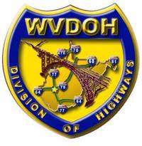DATE: March 11, 2025**

Ms. Sarah Runyon

Interim Technical Support Division Director

Technical Support Division

West Virginia Division of Highways

1900 Kanawha Blvd. Room 820

Charleston, West Virginia 25305

# SUBJECT: PUBLIC INVOLVEMENT

**PROJECT: SHILLING BRIDGE REPLACEMENT PROJECT**

**STATE PROJECT: S355-SHI/L-0.01 00**

**FEDERAL PROJECT: STBG 2023(082)D**

**OHIO COUNTY**

**COMMENTS DUE BY: Friday, April 18, 2025**

Please consider the following comments:

|  |
| --- |
|  |
|  |
|  |
|  |
|  |
|  |
|  |
|  |
|  |
|  |
|  |
|  |
|  |

(Please print the following information)

NAME:

ADDRESS:

ORGANIZATION (IF ANY):

|  |
| --- |
| Project information and comment sheet can be found online at the following WVDOH Website:  [https://transportation.wv.gov/highways/TechnicalSupport/CommentsOnProjects/Pages/Shilling\_Bridge\_Replacement.aspx](https://url.us.m.mimecastprotect.com/s/KSI8CDkxWRHMPyDDh5h4Hj_E_N?domain=transportation.wv.gov" \t "_blank) |