**Upcoming Informational Workshop Public Meeting**

**RAND DRAINAGE, Phase 1 and Phase 2**

**State Project S320-RAN/D-21. 00**

**Rand, WV**

**Kanawha County, WV**

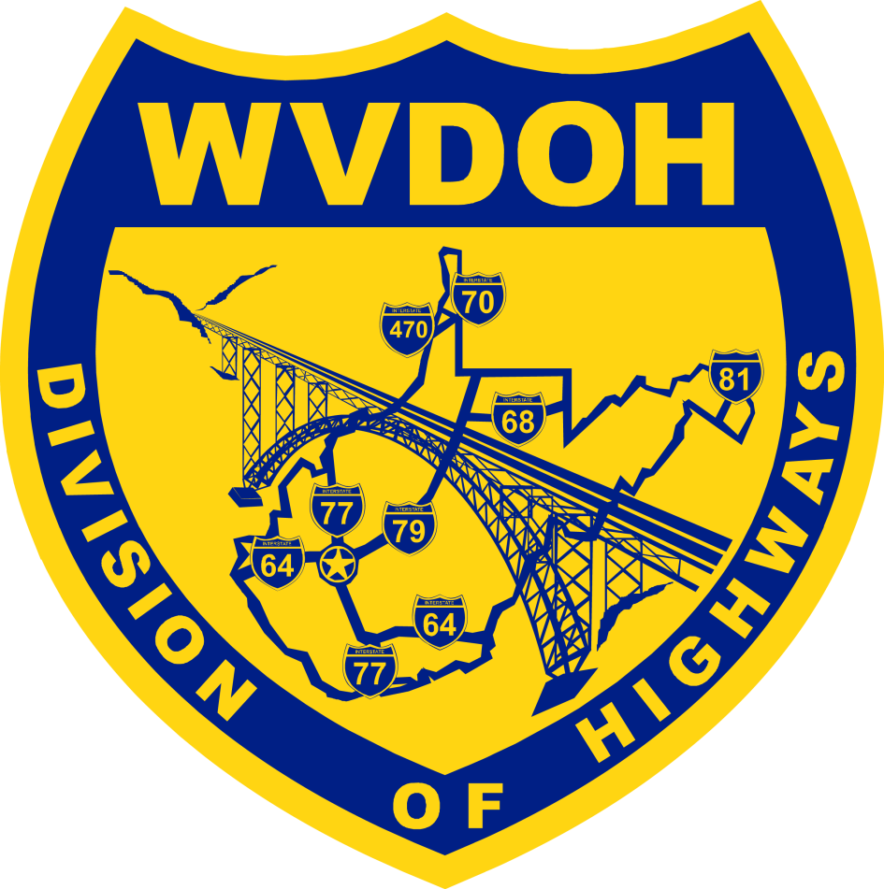



**Join us on Tuesday, October 18, 2022, from 4:00 pm to 7:00 pm, at the Rand Community Center for an informational workshop public meeting on the Rand Drainage project.**

**West Virginia Division of Highways (WVDOH) project representatives will be available to discuss the proposed project and answer questions. There will be no formal presentation, but project maps and other information will be on display.** **This meeting complies with the public involvement requirements of the National Environmental Policy Act (NEPA) and Section 106 of the National Historic Preservation Act.**

**Project** **Background**

**Historic maps show the community of Rand was built around a slough, a tributary to the Kanawha River**. T**his slough remains the accumulation area for stormwater and persistently floods homes and properties as there is inadequate drainage collection and outlets to the Kanawha River. Construction plans are being developed to help address the chronic flooding.**

**When and Where?**

**Tuesday, October 18, 2022**

**4:00 PM to 7:00 PM**

**Rand Community Center**

**5701 Church Drive**

**Rand WV**

**Upon request, WVDOH will provide reasonable accommodations to afford an individual with a disability an equal opportunity to participate. Please contact us at (304) 558‐3931, or (800)**

**982‐8722 (voice to TTD), or (800) 982‐8771 (TDD to voice).**

**To** **Comment**

Comments on the project are due Friday, November 18, 2022, and can be submitted at the meeting or sent to:

**Mr. Travis Long**

**Director, Technical Support Division WVDOH**

**1334 Smith Street**

**Charleston, WV 25301**

Visit our website at

[http://go.wv.gov/dotcomment.](http://go.wv.gov/dotcomment) under Public Comments, Engineering Projects, Open, then Rand Drainage Project